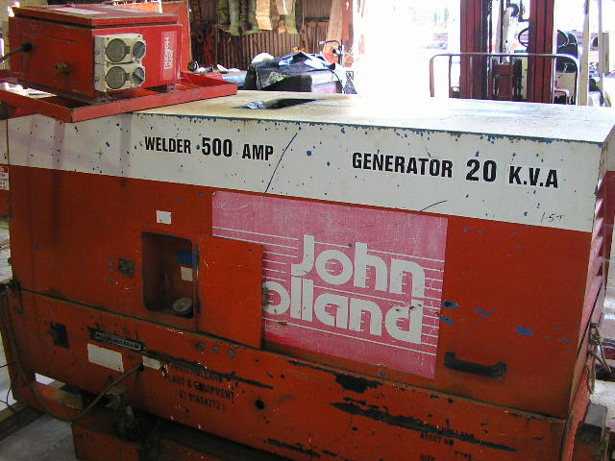 | Hazard Information Sheet
  Equipment: | Generator/Welders
 | Equip Type: | Generator/Welders
 | Generic Description or  Specific Make / Model: | Generator/Welders
 | Type: | Diesel
 | Other Details

Operator Requirements: | Operators must be trained and competent to use this equipment safely.
Purpose For Which This Equip Is Designed: | Electric Welding

Hazards & Risks:
Control Measures:
Electrical shock or burns due to:  1. Nicked, cut or damaged welding leads and/or 240v cables. | (i) Periodic inspection of welding leads and/or electric cables for nicks, cuts or damage.  (ii) Ensure welding leads not held against bare skin (over neck etc) especially in hot, sweaty humid environments as small unidentified nicks in leads can cause electrocution.  (ii) Ensure welding leads and/or electric cords not positioned in or near water nor likely to get damaged from falling objects, or pedestrian or other traffic.
2. Physical contact with the electrode or work (ground circuit). | (I) The electrode and work (ground circuits) are electrically “hot” when the welder is on. Do not touch these “hot” parts. (Wear dry, hole-free gloves.)  (ii) Insulate yourself from work and ground.  (iii) Ground work or metal to be welded to a good electrical (earth) ground.
3. Electric shock or burns due to damaged or poorly maintained electrical leads and cables. | (i) Periodic inspection of electric cables for nicks, cuts or damage.  (ii) If generator needs to be hard wired, connection of cables to be done by licenced electrician only.  (iii) Ensure power supply is RCD protected.  (iv) Test RCD operation prior to use.  (v) Ensure any cables on ground are not positioned in or near water, and are adequately protected from falling objects, or pedestrian or other traffic.

Disclaimer: In fulfilment of its statutory obligations, (ARS) & John Holland has taken what it considers to be all reasonable precautions and exercised due diligence to ensure that it has provided all relevant information on the safe use of the plant. However, except as required by law and only to the extent so required, (ARS) & John Holland does not make any representation, warranty or undertaking, express or implied, as to, or accept any responsibility or liability for, the accuracy or completeness of, or any errors in or omissions from, this Hazard Information Sheet. Except as required by law and only to the extent so required, neither (ARS) & John Holland nor any of its respective directors, officers, agents, or employees shall in any way be liable directly or indirectly to any person or body for any loss or damages, costs or expenses whatever arising out of | Date: 19/06/06
Equipment: | Generator/Welders  Diesel

Hazards & Risks: | Control Measures:
Suffocation:  Machine could be sited in a confined space and cause asphyxiation. | Operator instruction — site machine in well ventilated area.
Fumes/gases produced when welding can be injurious to health. | Avoid breathing fumes or gases produced when welding.
Explosion:  If used near flammable liquids or in an explosive atmosphere, sparks from welding can cause an explosion or fire. | User instruction not to weld in presence of flammable liquids or explosive atmospheres.
PPE (Personal Protective Equipment):  Welding flash is injurious to eyes. | Welders and observers to use shield with the proper filter and cover plates to protect eyes from sparks, and the rays of the arc when welding is in progress. Headshield and filter lens should conform to relevant Australian Standards.
Noise:  Exposure to noise. | Personnel working with or in the vicinity of this equipment to wear suitable hearing protection.
Entanglement:  Becoming entangled in moving parts | Equip to run with doors closed. Shut generator/welder down if necessary to access engine compartment.
High Temperature or Fire:  Refuelling: When refuelling, sparks, flames, hot engine can ignite fuel. | Before refuelling, operator to shut down engine and turn off all electrical switches. When refuelling, ensure that there are no naked flames in the area. DO NOT SMOKE. Avoid spilling fuel and collect any fuel run off.
Welding: When welding, sparks from welding can ignite flammable products (rag, paper etc). | User instruction to ensure good housekeeping around work area.

Disclaimer: In fulfilment of its statutory obligations, (ARS) & John Holland has taken what it considers to be all reasonable precautions and exercised due diligence to ensure that it has provided all relevant information on the safe use of the plant. However, except as required by law and only to the extent so required, (ARS) & John Holland does not make any representation, warranty or undertaking, express or implied, as to, or accept any responsibility or liability for, the accuracy or completeness of, or any errors in or omissions from, this Hazard Information Sheet. Except as required by law and only to the extent so required, neither (ARS) & John Holland nor any of its respective directors, officers, agents, or employees shall in any way be liable directly or indirectly to any person or body for any loss or damages, costs or expenses whatever arising out of or in connection with the information contained in this Hazard Information Sheet. | Date: 19/06/06

